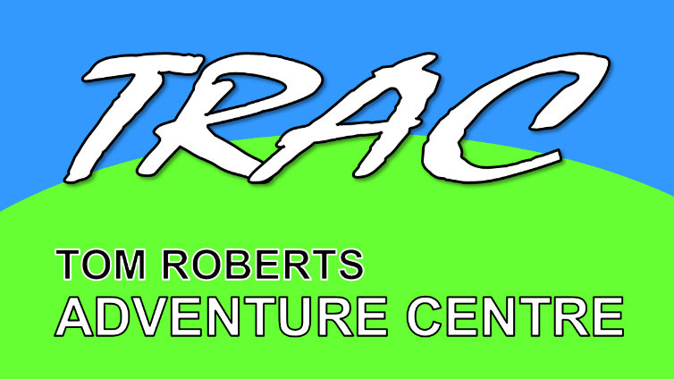
Tom Roberts Adventure Centre
Yates Farm, Malswick, Newent Gloucestershire, GL18 1HE
www.tracnewent.org.uk
MINOR INJURIES UNIT (MIU)
Minor Injuries Units at community hospitals treat a variety of injuries and illness for adults and children. No appointment is needed.
If your injury is not serious you can get help from a MIU rather than emergency department. By doing so you allow emergency department staff to concentrate on people with serious and life-threatening conditions and save yourself a potentially long wait.
The MIU team specialise in:
- Sprains
- Simple fractures needing x-rays and plasters
- Simple wounds that may need stitches
- Minor burns
- Emergency contraception
- Minor head injuries with no loss of consciousness
- Eye conditions including foreign bodies and conjunctivitis
- Skin problems such as rashes, bites, stings and infections
- Minor illness, earache, sore throat (when your GP PRACTICE IS CLOSED)
Nearest Minor Injury Units:

- Tewkesbury Hospital Monday – Sunday 0800–2000
Barton Rd, Gloucestershire, Tewkesbury GL20 5GJ 28 Mins - 15 Miles
0300 421 6100

- Ledbury Community Health Monday – Sunday 24 hours
Market St, Ledbury HR8 2AQ 19 minutes – 10.1 miles
01531 632488

- Ross-on-Wye Community Hospital Monday – Friday 0830 -1800
Alton St, Ross-on-Wye HR9 5AD 19 Minutes – 10.9 Miles
01989 562100

NEAREST A&E
- Gloucester Royal Hospital 24 Hours
Great Western Rd, Gloucester GL1 3NN 20 Mins – 8.4 Miles
0300 422 2222

